Mathematics Level 1


Items highlighted in yellow are tasks for you to complete
Items in Blue italics are help tips

Level 1 Mathematics Quiz

Which of the pieces below fits into the space shown?

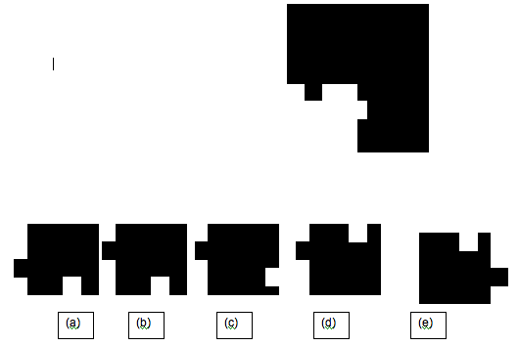

Answer (a)

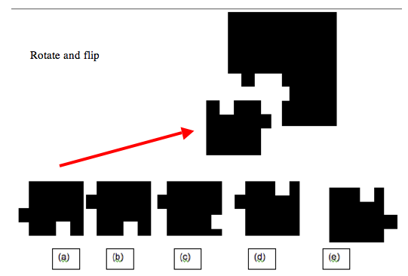

Question 2

Add together the first five even
numbers.

Answer 30

2+4+6+8+10
Question 3

Write down any prime number
between 50 and 60.

Answer 53 & 59
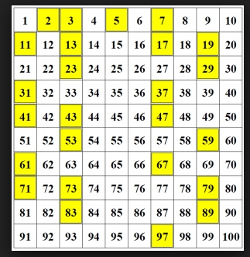

Question 4

Petrol costs
$1.84 per litre.
How much will
64 litres cost?

Answer: $117.76

64x1.84
Question 5

PRIME
TIME

2, 3, 5, 7, …

If I add up all the prime numbers between 10 and 20, what total do I get?

Answer: 60

Question 6

Find the first two numbers in this sequence:

__ , __ , 7, 10, 14, 19, 25, …

Answer: 4, 5

Add by +1 each time
4 + 1 = 5, 5 + 2 = 7, 7 + 3 = 10, 10 + 4 = 14, 14 + 5 =19, 19 + 6 = 25
Question 7

Which sequence comes next

D F H J
J D F H
H J D F
? ? ? ?

Answer: F H J D (move forward by 1)

Question 8

A sick man takes 2 pills every morning and 1 pill
each night.

How many pills does he take in October?

Answer: 93 (3 x 31)
31 days in October
Question 9

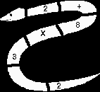

Perform the calculation
shown in the death adder

Answer: 14
3/2 =1.5 , * 8 = 12 + 2 = 14

Question 10
Calculate:
x x ¾ x x
Answer 1/6

1 | x | 2 | = | 1 | x | 3 | = | 1 | x | 4  / | = | 1 | x | 5 | = | 1
2 | x | 3 | = | 3 |  | 4 | = | 4  / | x | 5 | = | 5 | x | 6 | = | 6
making fractions
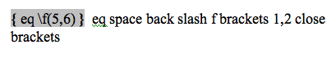
eq space back slash f brackets 1,2 close brackets
Right mouse click
x
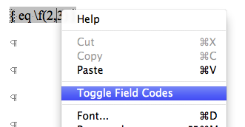

$$2\begin{aligned}\frac{5}{}\end{aligned}$$

Double click on fraction to change but will be smaller
2/3 x 1/2 = 2/6 = 1/3.

Question 11
Calculate

Answer 0

(4x5) = 20 +
(3x2) = 26-
(16/4) = 22-
12 = 10
-(20/2) = 0


Question 12

MUSICAL MAGIC

A brass band of 40 musicians

Takes 4 minutes to play a March. How long would it Take a band of 60 musicians?

Answer 4 min


Need help just ask

